Loading CelebA

* Download Issue

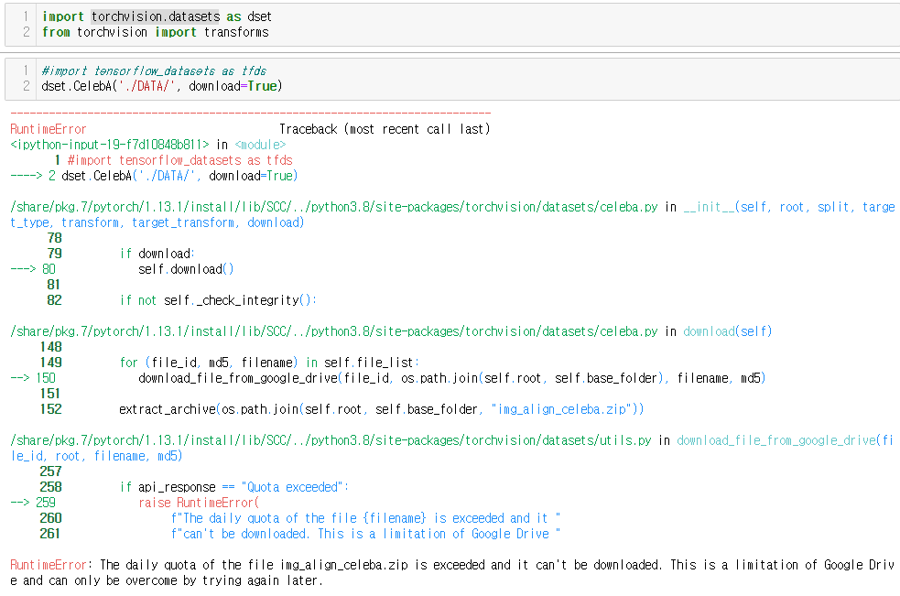

* Used Kaggle [<https://www.kaggle.com/datasets/jessicali9530/celeba-dataset?resource=download>]
  + # of images: 202599 ~ 200k.
  + Data partition: 162770., 19867., 19962.

→ File Quota exceeds in SCC environment. Need to reduce the size!

* Selecting Features for the training set.
  + No
    - `Blurry` (10312)
    - `5_o_Clock_Shadow` (22516)
  + Picture with some label
    - Of hair color or hair style (straight / wavy)
      * This potentially eliminate portraits with hats

Example:

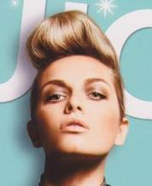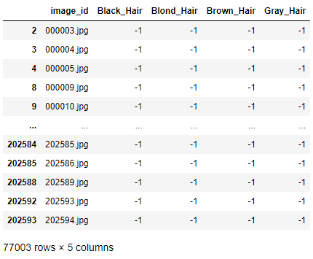

000005.jpg → No label.

* + Discarding ~Mustache & ~No_Beard (i.e. Beard only - not very reliable. I mean, who does that, except this guy?)

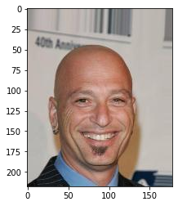

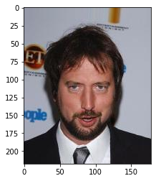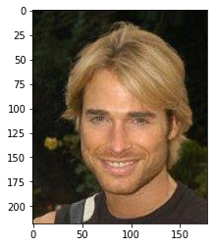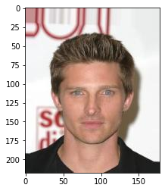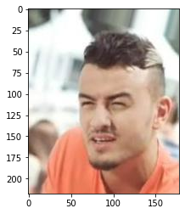

* + - **As the result, we get 66183 photos.**

|  | **ATTR** | **BEFORE_CNT** | **AFTER_CNT** | **Decreased%** |
| --- | --- | --- | --- | --- |
| **0** | 5_o_Clock_Shadow | 22516 | 0 | 100 |
| **1** | Arched_Eyebrows | 54090 | 23549 | 56 |
| **2** | Attractive | 103833 | 42984 | 59 |
| **3** | Bags_Under_Eyes | 41446 | 10252 | 75 |
| **4** | Bald | 4547 | 2864 | 37 |
| **5** | Bangs | 30709 | 12510 | 59 |
| **6** | Big_Lips | 48785 | 18981 | 61 |
| **7** | Big_Nose | 47516 | 11347 | 76 |
| **8** | Black_Hair | 48472 | 20463 | 58 |
| **9** | Blond_Hair | 29983 | 18957 | 37 |
| **10** | Blurry | 10312 | 0 | 100 |
| **11** | Brown_Hair | 41572 | 23255 | 44 |
| **12** | Bushy_Eyebrows | 28803 | 7730 | 73 |
| **13** | Chubby | 11663 | 3042 | 74 |
| **14** | Double_Chin | 9459 | 2702 | 71 |
| **15** | Eyeglasses | 13193 | 2829 | 79 |
| **16** | Goatee | 12716 | 936 | 93 |
| **17** | Gray_Hair | 8499 | 3119 | 63 |
| **18** | Heavy_Makeup | 78390 | 38131 | 51 |
| **19** | High_Cheekbones | 92189 | 37298 | 60 |
| **20** | Male | 84434 | 15572 | 82 |
| **21** | Mouth_Slightly_Open | 97942 | 34324 | 65 |
| **22** | Mustache | 8417 | 1601 | 81 |
| **23** | Narrow_Eyes | 23329 | 7512 | 68 |
| **24** | No_Beard | 169158 | 64631 | 62 |
| **25** | Oval_Face | 57567 | 22371 | 61 |
| **26** | Pale_Skin | 8701 | 3162 | 64 |
| **27** | Pointy_Nose | 56210 | 22030 | 61 |
| **28** | Receding_Hairline | 16163 | 3416 | 79 |
| **29** | Rosy_Cheeks | 13315 | 6983 | 48 |
| **30** | Sideburns | 11449 | 610 | 95 |
| **31** | Smiling | 97669 | 36903 | 62 |
| **32** | Straight_Hair | 42222 | 23771 | 44 |
| **33** | Wavy_Hair | 64744 | 40365 | 38 |
| **34** | Wearing_Earrings | 38276 | 15237 | 60 |
| **35** | Wearing_Hat | 9818 | 277 | 97 |
| **36** | Wearing_Lipstick | 95715 | 45488 | 52 |
| **37** | Wearing_Necklace | 24913 | 11074 | 56 |
| **38** | Wearing_Necktie | 14732 | 3829 | 74 |
| **39** | Young | 156734 | 53863 | 66 |

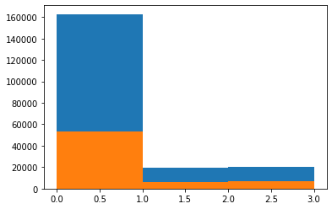partition before / after applying data selection condition.

To deal with data imbalance issues,

Male / Female ratio

Young / ~Young ratio

StyleGAN2.

Pretraining

(0)

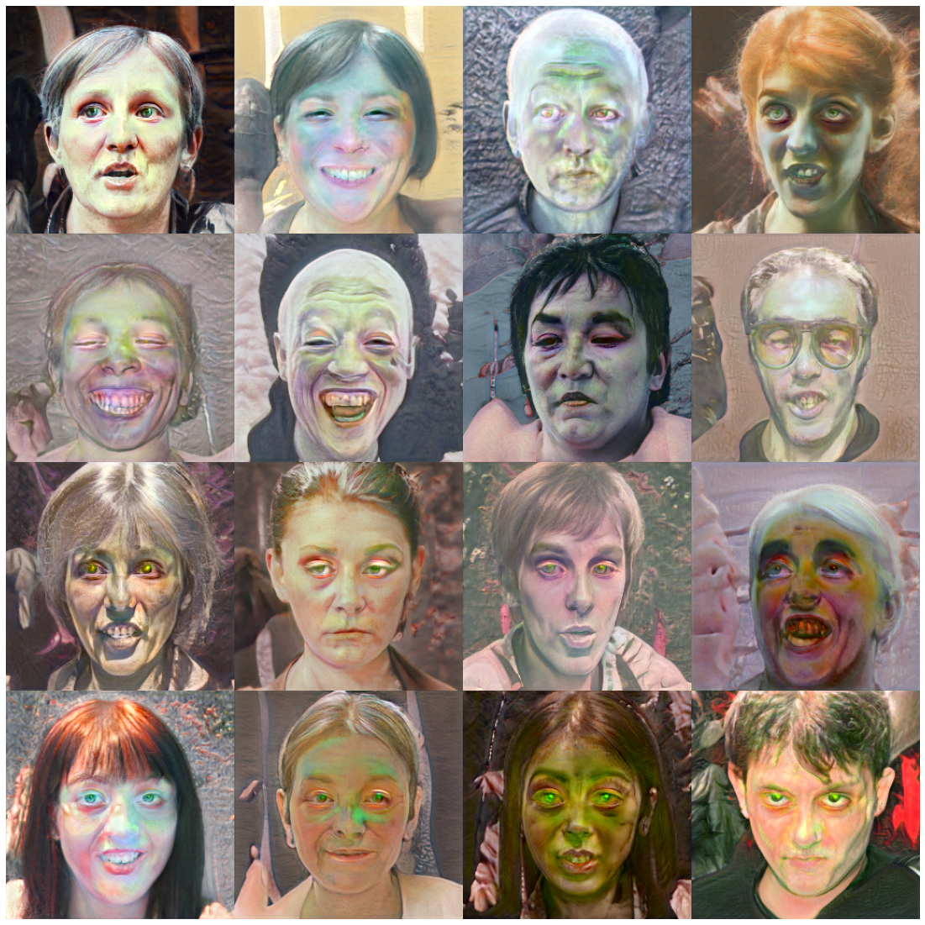

(120)

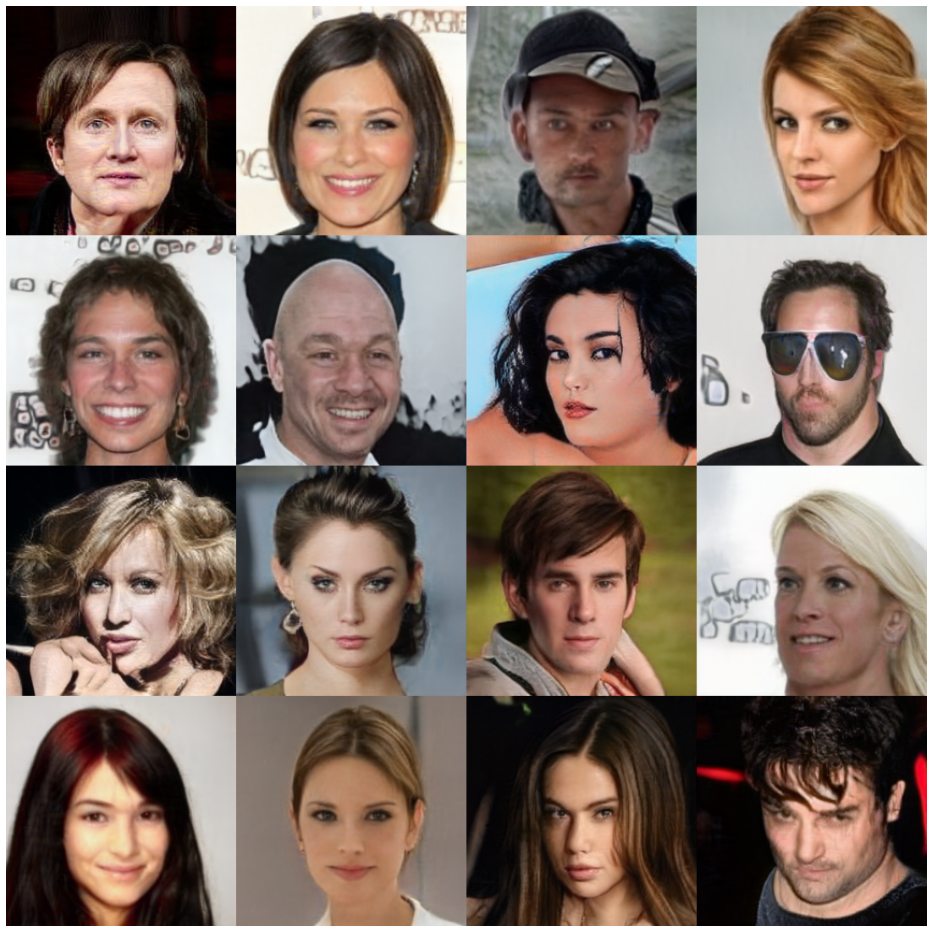

GAN Inversion

* Target

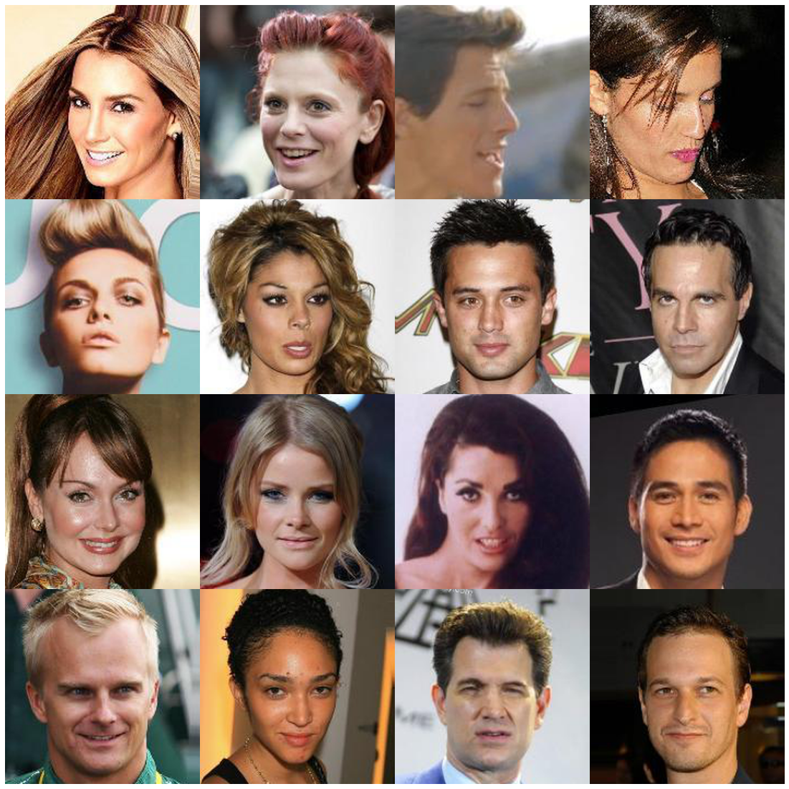

* Overfitting by projection(256 steps)

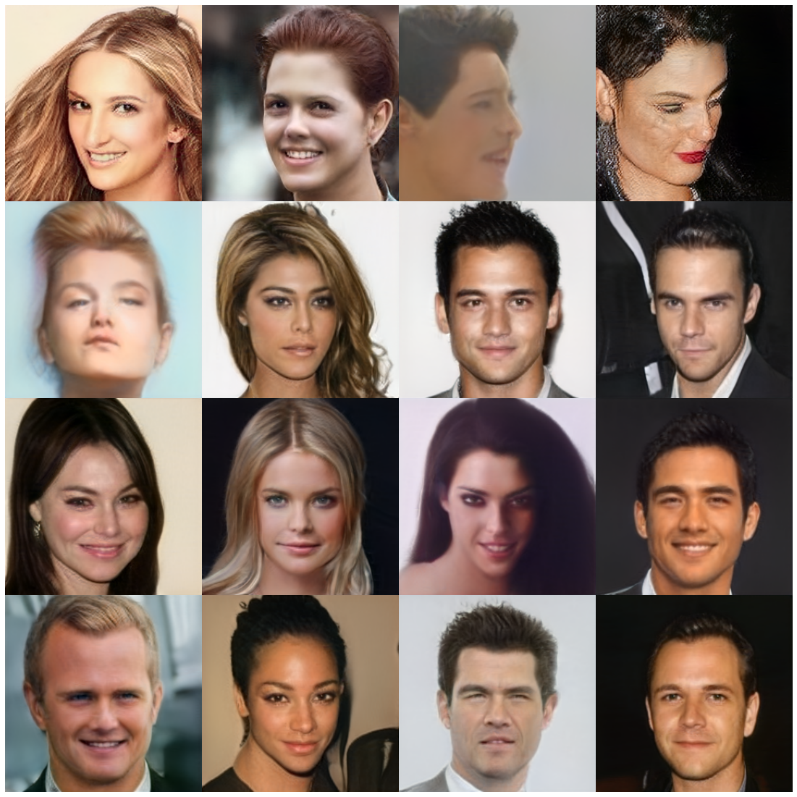

* Training Encoder (10epochs)

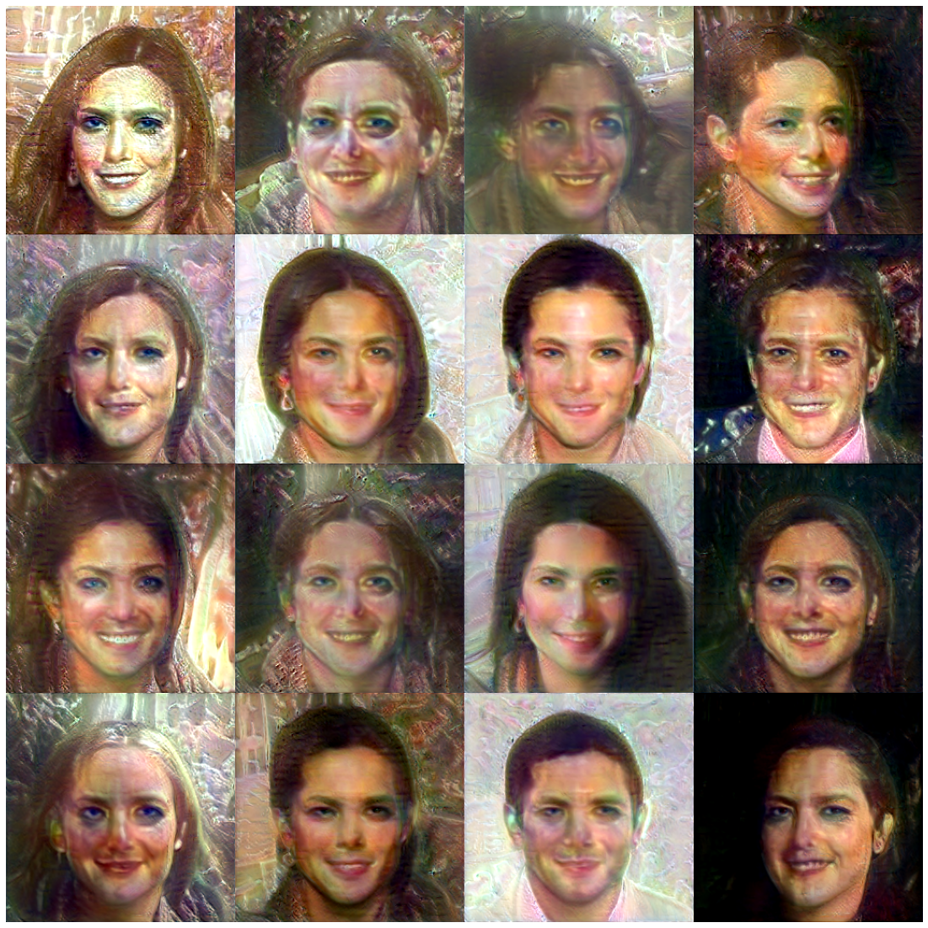

(20)

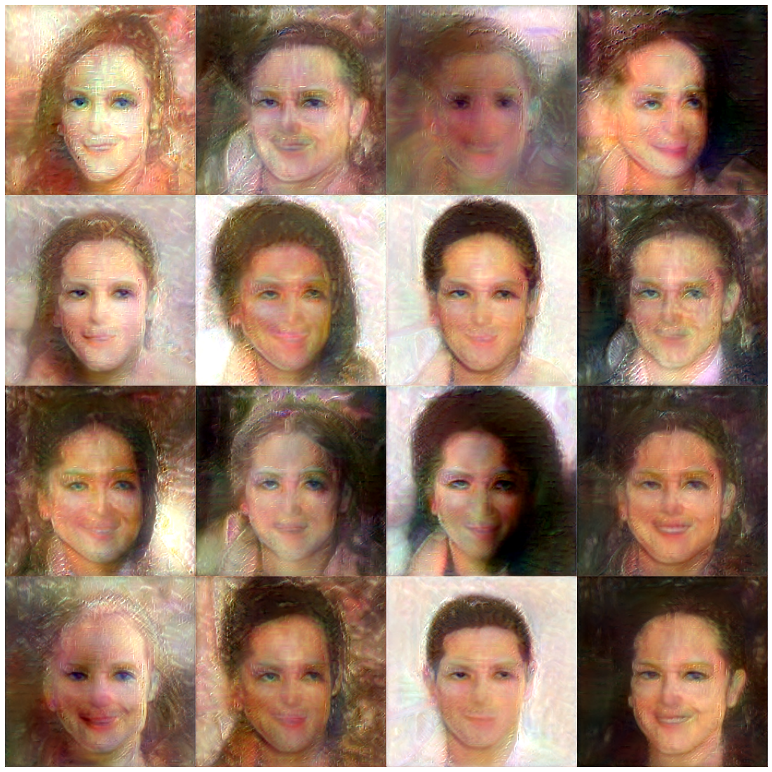

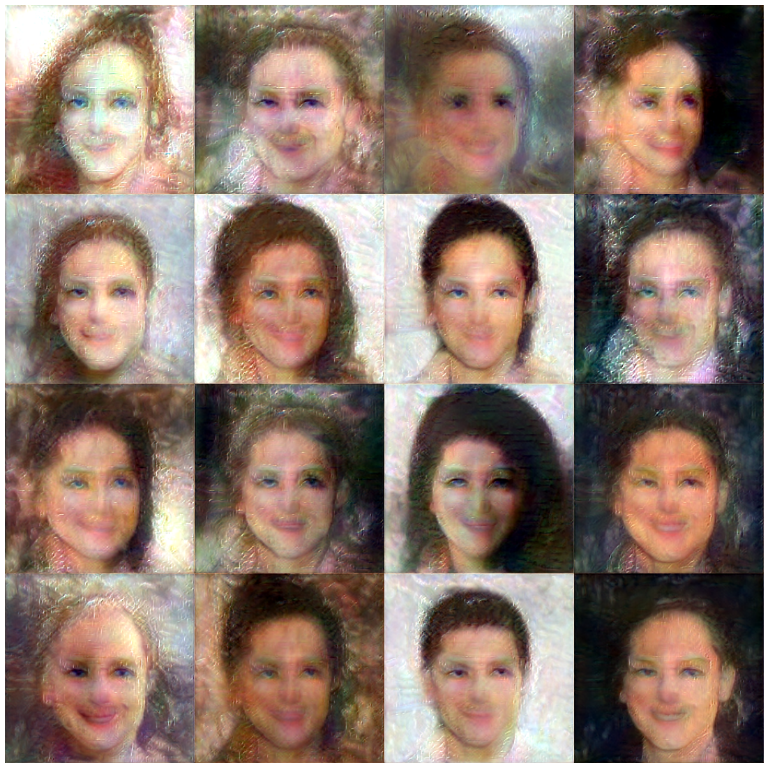

* Encoder trained with overfitted guide embedding

(110)

